**Begin building the artisanal e-commerce platform on IBM Cloud Foundry:**

Building an artisanal e-commerce platform on IBM Cloud Foundry is a complex task that involves several steps and technical expertise. Here's a high-level outline to get you started:

* Setup IBM Cloud Account:

Sign up for an IBM Cloud account if you don't already have one.

* Install Cloud Foundry CLI:

Download and install the Cloud Foundry Command Line Interface (CF CLI) to interact with IBM Cloud Foundry.

* Create a Cloud Foundry Space:

Create a space within IBM Cloud Foundry to organize your application.

* Choose a Tech Stack:

Decide on the technology stack you want to use for your e-commerce platform, including the programming language and database.

* Develop Your Application:

Write the code for your e-commerce platform, implementing features like product listings, shopping cart, user authentication, and payment processing.

* Database Setup:

Set up a database service within IBM Cloud to store product data, user information, and order history.

* User Authentication:

Implement user authentication and authorization to secure your platform.

* Payment Integration:

Integrate a payment gateway for processing transactions securely.

* Frontend Development:

Create the frontend of your platform using web development technologies like HTML, CSS, and JavaScript.

* Testing and Quality Assurance:

Thoroughly test your application to ensure it's free of bugs and works as expected.

* Deployment:

Use the CF CLI to deploy your application to IBM Cloud Foundry.

* Scale and Load Balancing:

Configure auto-scaling and load balancing to handle varying levels of traffic.

* SEO and Marketing:

Implement SEO best practices and marketing strategies to attract customers.

* Compliance:

Ensure your platform complies with relevant regulations, such as GDPR for user data privacy.

* Continuous Improvement:

Regularly update and improve your platform based on user feedback and changing requirements.

* Backup and Disaster Recovery:

Implement backup and disaster recovery solutions to protect your data.

* Documentation and Support:

Create user and developer documentation, and provide support channels for your users.

This is a simplified overview, and building a complete e-commerce platform can be a substantial project. You may also want to consider using IBM Cloud services and solutions specific to e-commerce, like IBM Watson Commerce, to expedite development. It's recommended to consult IBM's official documentation and consider seeking professional development assistance if needed.

**DESIGN & PLATFORM LAYOUT:**

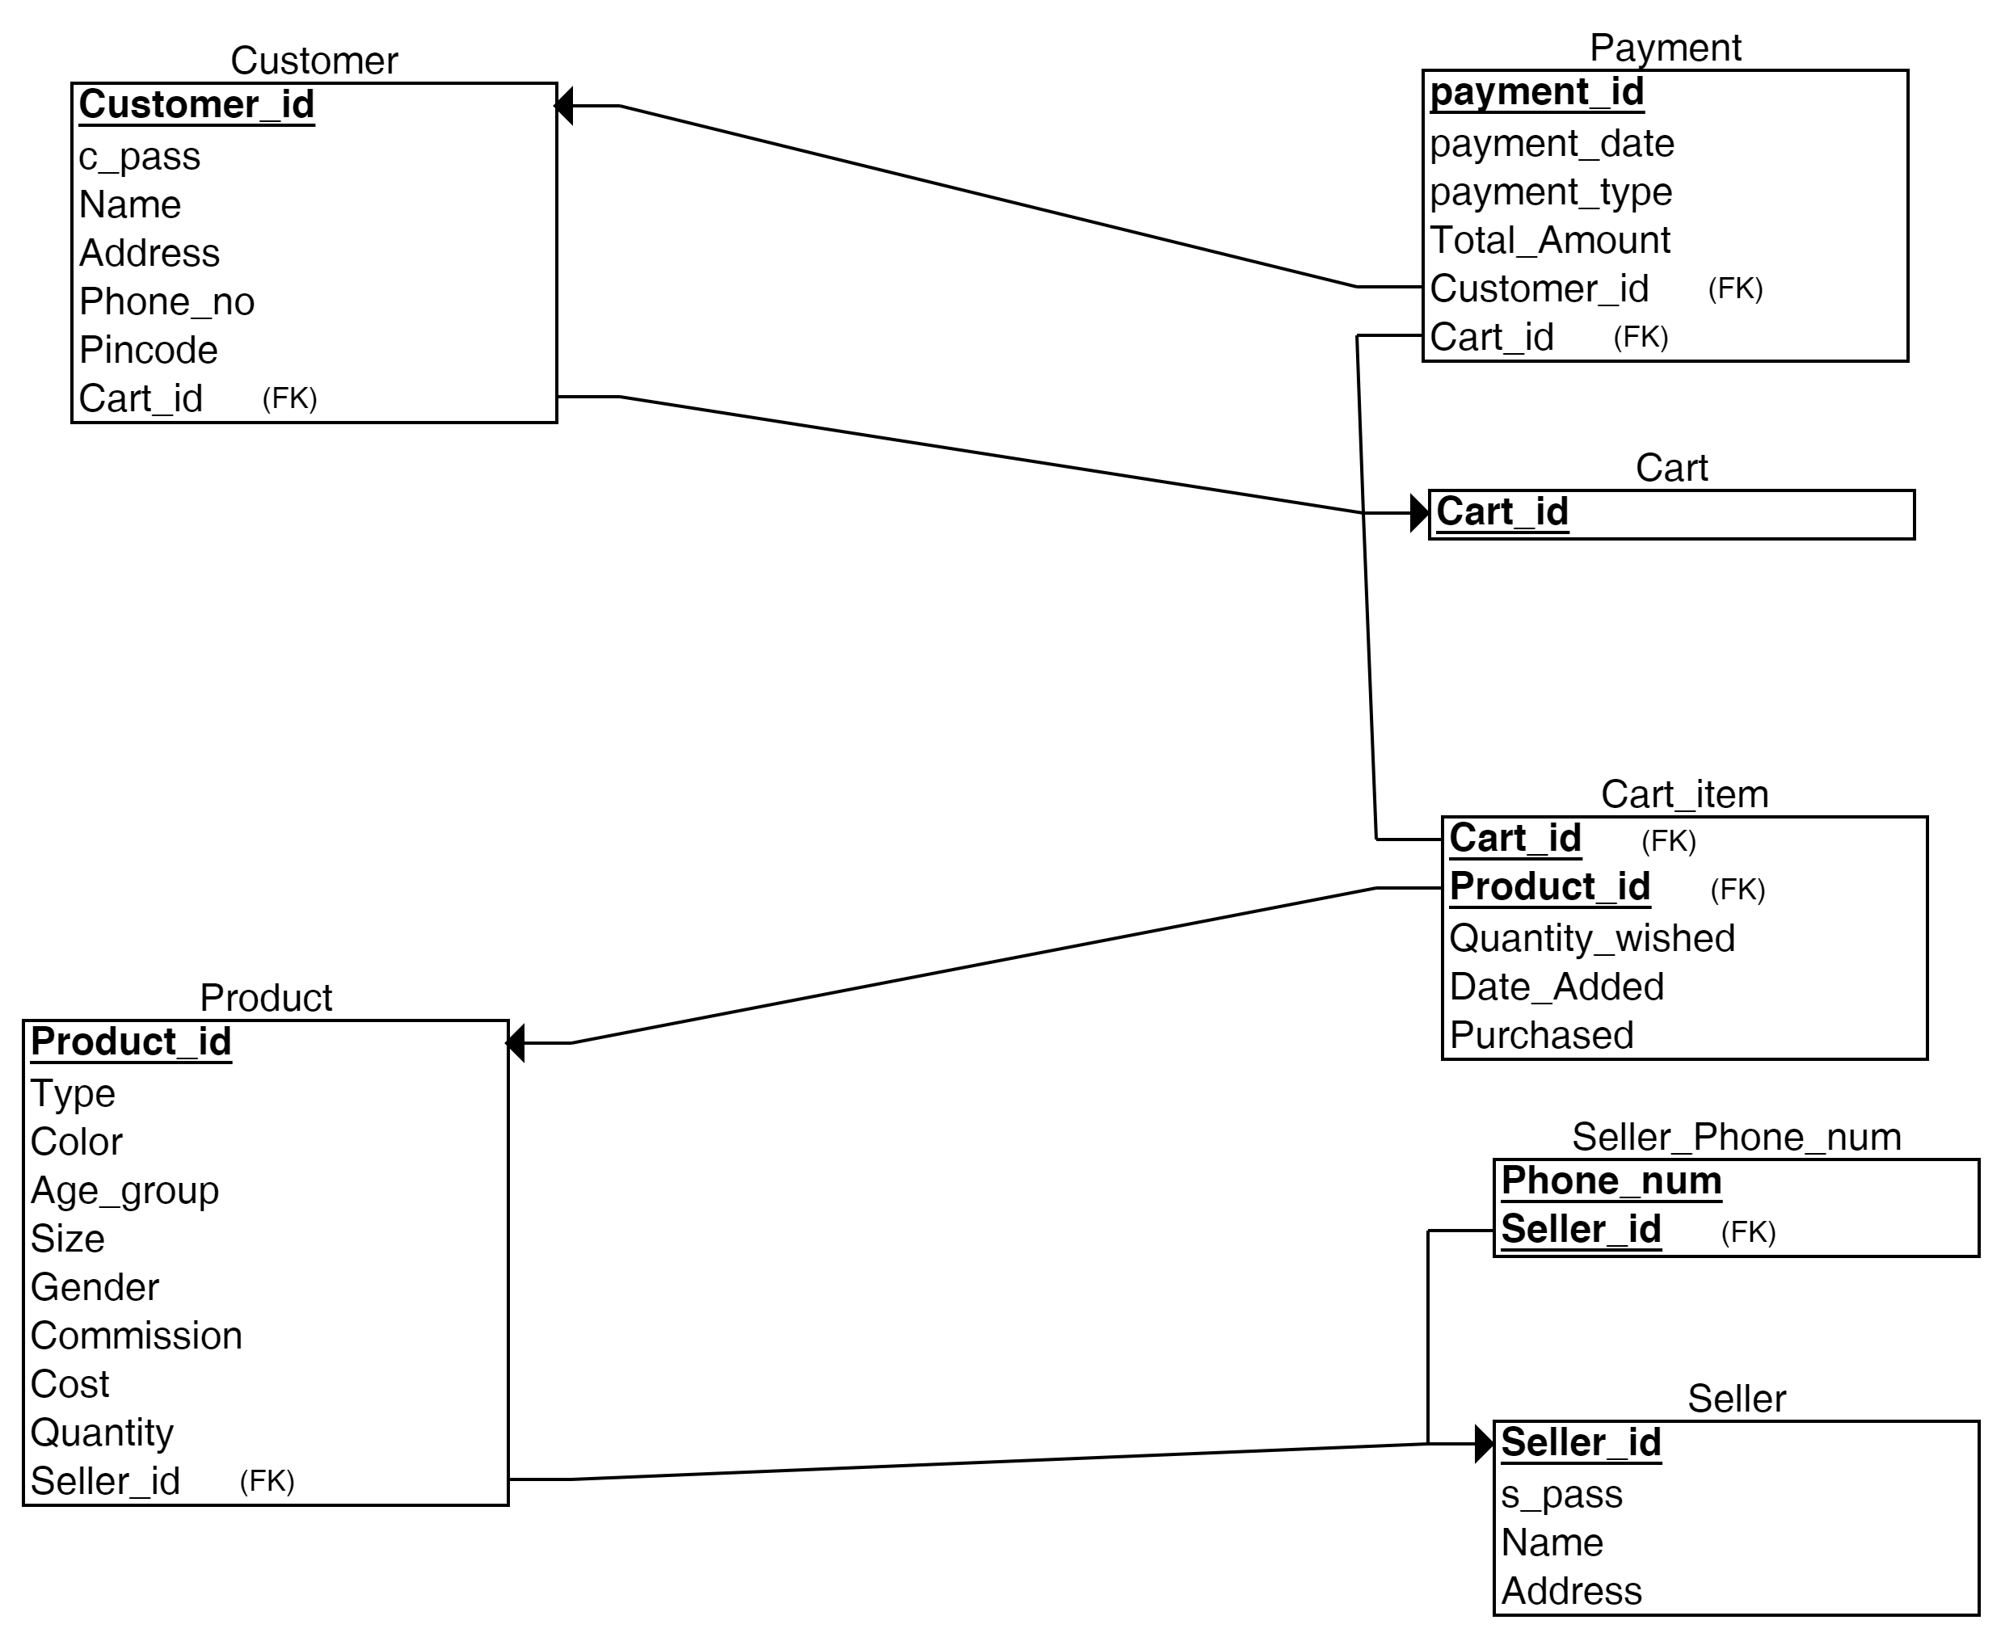

**Website Layout:**

1. Homepage: Display featured products, categories, and a search bar.
2. Product Listing Page: Show products with images, prices, and descriptions.
3. Product Details Page: Display detailed information about a product.
4. Shopping Cart: Allow users to add and manage their selected products.
5. Checkout Page: Gather shipping and payment information.
6. User Account: Enable user registration, login, and order history.
7. Admin Dashboard: Manage products, orders, and user accounts.

**Database Design:**

1. Product Table: Fields might include Product ID, Name, Description, Price, Quantity, Category, and Images.
2. User Table: Store user information like User ID, Name, Email, Password (hashed), and Address.
3. Order Table: Track orders with Order ID, User ID (foreign key), Product ID (foreign key), Quantity, Total Price, and Order Date.

**Development Tools:**

1. Front-end: HTML, CSS, JavaScript, and a framework like React or Angular.
2. Back-end: A server-side language (e.g., Node.js, Python, Ruby) and a web framework (e.g., Express, Django, Ruby on Rails).
3. Database: MySQL, PostgreSQL, or NoSQL databases like MongoDB.
4. Web server: Apache, Nginx.
5. Hosting and Domain: Choose a web hosting service and register a domain name.
6. Security: Implement HTTPS, authentication, and data validation to protect user information.
7. Payment Integration: Use a service like Stripe, PayPal, or integrate other payment gateways.

**Source Code:**

-- Create a new database (if it doesn't already exist)

CREATE DATABASE ecommerce_db;

-- Use the newly created database

USE ecommerce_db;

-- Create a "Product" table to store product information

CREATE TABLE Product (

ProductID INT AUTO_INCREMENT PRIMARY KEY,

Name VARCHAR(255) NOT NULL,

Description TEXT,

Price DECIMAL(10, 2) NOT NULL,

StockQuantity INT NOT NULL,

Category VARCHAR(50),

ImageURL VARCHAR(255),

CreatedAt TIMESTAMP DEFAULT CURRENT_TIMESTAMP,

UpdatedAt TIMESTAMP DEFAULT CURRENT_TIMESTAMP ON UPDATE CURRENT_TIMESTAMP

);

In this example, the "Product" table has the following fields:

ProductID: An auto-incremented primary key for each product.

Name: The name of the product.

Description: A text description of the product.

Price: The price of the product.

StockQuantity: The quantity of the product in stock.

Category: The category to which the product belongs.

ImageURL: A URL pointing to the product's image.

CreatedAt and UpdatedAt: Timestamps to track when the product was created and last updated.

**User Table:**

- If your ecommerce website requires user accounts, you can create a "User" table to store user information. Here's a simplified example:

CREATE TABLE User (

UserID INT AUTO_INCREMENT PRIMARY KEY,

Username VARCHAR(50) NOT NULL,

Email VARCHAR(255) NOT NULL,

Password VARCHAR(255) NOT NULL,

Address VARCHAR(255),

RegistrationDate TIMESTAMP DEFAULT CURRENT_TIMESTAMP

);

**Order Table:**

- To track customer orders, create an "Order" table:

CREATE TABLE Order (

OrderID INT AUTO_INCREMENT PRIMARY KEY,

UserID INT,

OrderDate TIMESTAMP DEFAULT CURRENT_TIMESTAMP,

TotalAmount DECIMAL(10, 2) NOT NULL,

FOREIGN KEY (UserID) REFERENCES User(UserID)

);

**OrderItem Table:**

- Store the individual items within each order in the "OrderItem" table:

CREATE TABLE OrderItem (

OrderItemID INT AUTO_INCREMENT PRIMARY KEY,

OrderID INT,

ProductID INT,

Quantity INT,

ItemTotal DECIMAL(10, 2) NOT NULL,

FOREIGN KEY (OrderID) REFERENCES Order(OrderID),

FOREIGN KEY (ProductID) REFERENCES Product(ProductID)

);

These are just a few examples of tables you might include in your ecommerce database. You can expand your database schema based on the specific requirements of your ecommerce website. Other tables you might need include tables for tracking payments, shipping information, and customer reviews.